## Root cause analysis-example

Low quality weights deliver to customers

Equipment broken

Staff not trained

Precedence not correct

Improper packing

Storage bin damage

No storage process

Damage during transport

Don’t identify defects

Poor processing

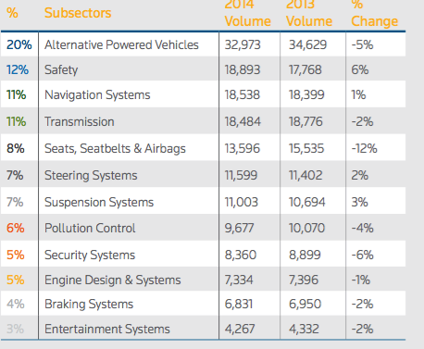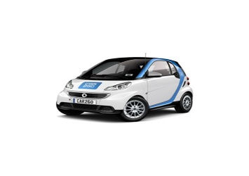

AUTOMOTIVE OVERVIEW